Bishop’s University
Computer Vision / Image Analysis – Winter 2021

Final Project

- Assignment

The objective of this project is to implement and to experiment the Mean Shift technique for image analysis tasks such as filtering, segmentation and target tracking.

- Requirements

You need to implement the Mean Shift strategy to perform only one of the following tasks: image filtering, image segmentation or target tracking. Figure 1 shows a sample of a gray scale image. Figure 2 shows a sample image of a color image.

The requirements below intend to specify what is to be done, but not how it should be done. The student should consider various design decisions for constructing the segmentation program.

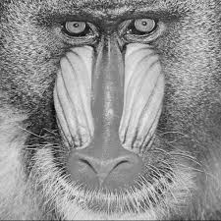

Figure 1: image input for filtering task

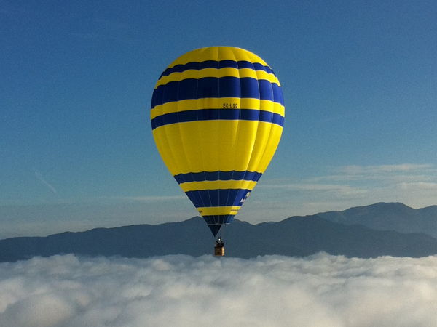

Figure 2: image input for segmentation task

Part 1:

- The program should give a brief greeting and announce its purpose

- The program should prompt the user for its input

- The program must allow the selection of the features to use. The features will be: color for ppm, gray scale intensity for pgm, and location. Your solution must work for both gray scale and color inputs.

- Important program steps must be clearly described. Program code or tools used, developed by others, should be documented. Code from previous assignments can be used. The core of the segmentation part, the smoothing part or the tracking part (i.e. Mean Shift) must be your own code.

- A document/ report must be submitted that shows the use of the program, the results, and some discussion of the results.

- Resources

      - Example test data files will be provided. For the target tracking part, you can generate your own video. Use a Libraries to extract the frames from the video
      - Check the documentation part for the papers to use depending on which part you decide to implement.

- Submission: report + program

You will submit 2 files: one containing your programming work (source code only) and one containing your report. For the electronic report of your results, you may use Word, PowerPoint, or other document processor to prepare the report. This report must have the following sections: 1) identification of person and assignment, 2) brief problem definition, 3) summary of choices made for the solution, 4) Segmentation results of 2 color and 2 gray scale images, 5) brief discussion of results. As a guideline, a well done report need only be 4 typed pages in addition to the pages showing the example results. Section 3) should mention choices of algorithm(s) and reuse of outside code.

- Notes

  - Partial credit will be given for partial completion of the tasks: thus, it is wise to always have a version of the program that correctly computes some of the required outputs.

  - It is unwise to work with large input images until the program steps are working correctly. It is too difficult to determine problems with large images.

- Deadline April 30th.

